No Sweat Mass Page Creator Recommend Resources & Plugins

Content
1. Introduction 3
2. Content Generation 3
3. Bulk Post/Pages Edition Plugins 4
4. Other usefull plugins Plugins 8
5. Plugins Only for Advanced Users 11
6. Other Resources to generate dynamic content 12

Introduction

The No Seat Mass Page Creator plugin uses a well-spun article template and one or more lists of keywords to minimize workload involved in the massive creation posts. Simply put, this plugin helps you create posts/pages in bulk within no time

In this document we suggest some free plugins we are sure will be useful (some even necessary!) companions for No Sweat Mass Page Creator users.

Bulk Post/Pages Edition Plugins

As we explain in the user guide, checking the spun article and the posts about to be published is critical. Once you have published them, No Sweat Mass Page Creator cannot change the articles.

After publishing some thousands of articles, modifying one by one because we made a spelling mistake, or changing the category of hundreds of articles would be an arduous task.

Nevertheless, there are some free plugins you may use that will help you make those bulk changes.

Let´s start!

  - Batch-Move Posts wp plugin

This plugin helps you change the category of a group of posts in large numbers. Just select the posts you want to change (using the current category, keywords etc) and move them to the new category automatically.

It can be used also to mass delete the identified articles.

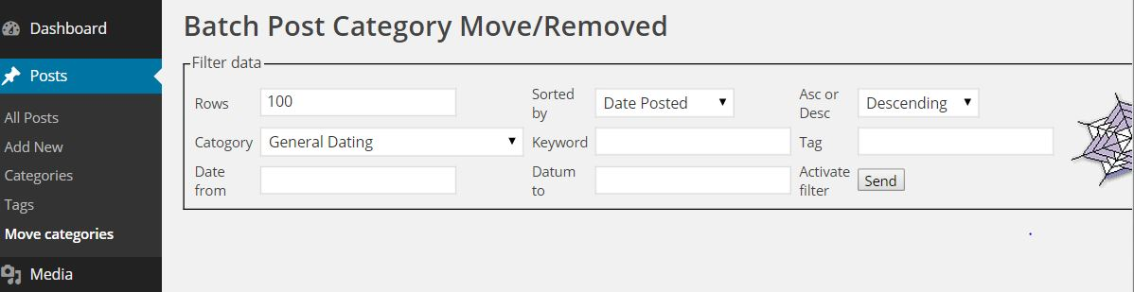

  - Search & Replace

After inserting thousands of articles you may notice that there is a grammar mistake in all your posts!. No problem, just use this plugin and everything will be fixed. Use it with care, as it modifies the database directly and once you execute it you cannot “undo” the changes.

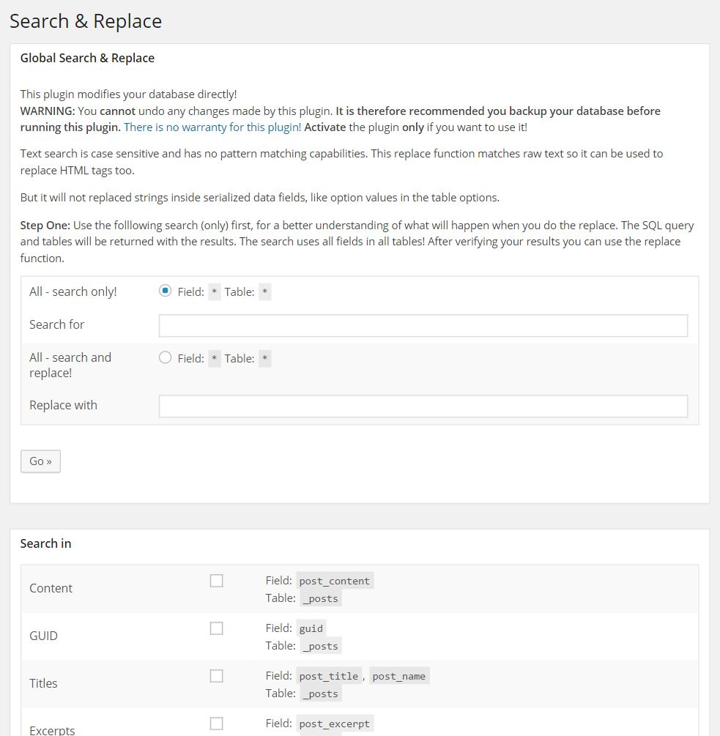

  - Permalink Finder

You have generated the project in No Sweat Mass Page Creator. You check it, everything is ok so you publish it.

Some days later you see an error in the title… and also in the URL of the posts. Ok, you may use the Search & Replace plugin, but what would happen if Google has already indexed your content?

Where will the users go when the click on Google´s links?... To a 404 error page!

Also, imagine you have modified the permalink structure… again same ERROR!

With this plugin, the user (and Google) will be redirected to the new URLs with no errors, keeping your SEO scores and user experience intact.

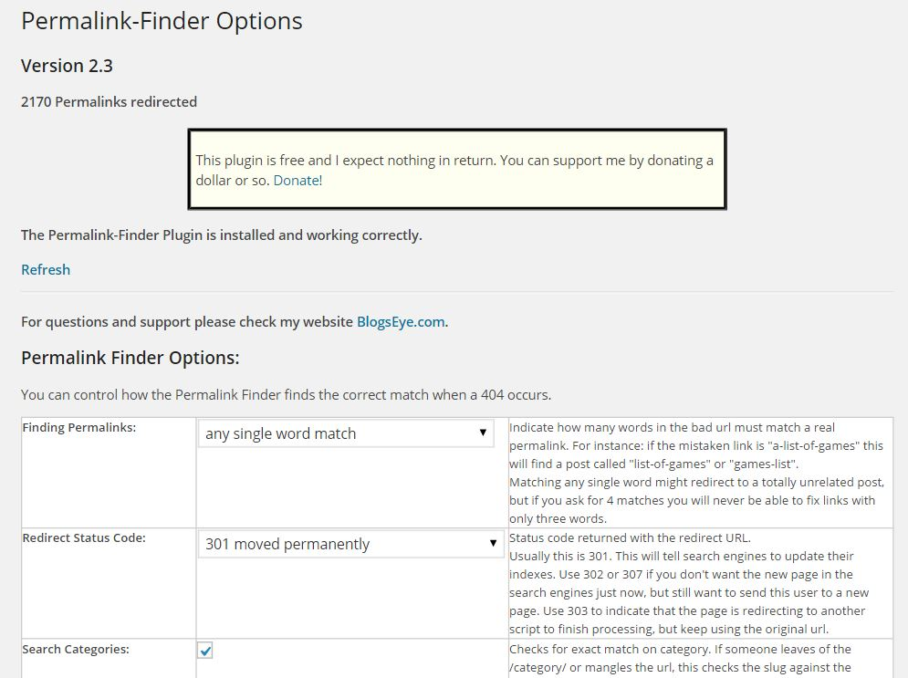

Other useful plugins Plugins

  - Widget Logic

The problem with massively automated generated content comes when you want to manage group of posts or categories independently.

Imagine you want to show a different banner in the sidebar of each post depending on the post's category.

How can you do that?

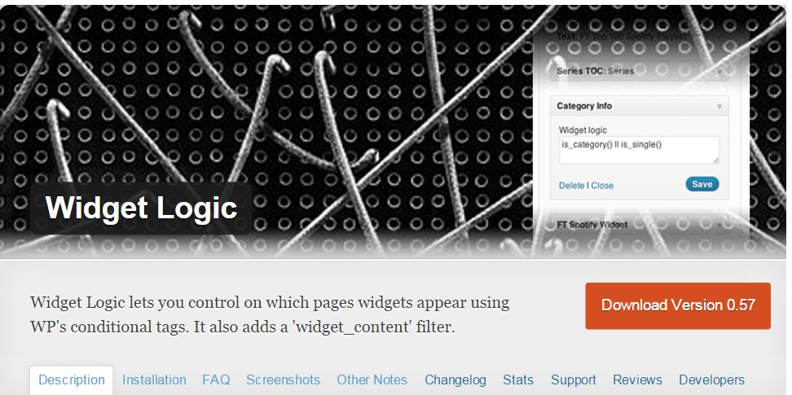

With Widget Logic you will be able to control the widgets that appear using conditional tags... and much more!

  - Call to Action

Monetization is one of the most (Ok, the most!) important things for Internet Marketers. But, how can we test our Banner or texts if we have published thousands of articles?

If we decide to change a banner that was inside our posts after we have published them, how can we do it?

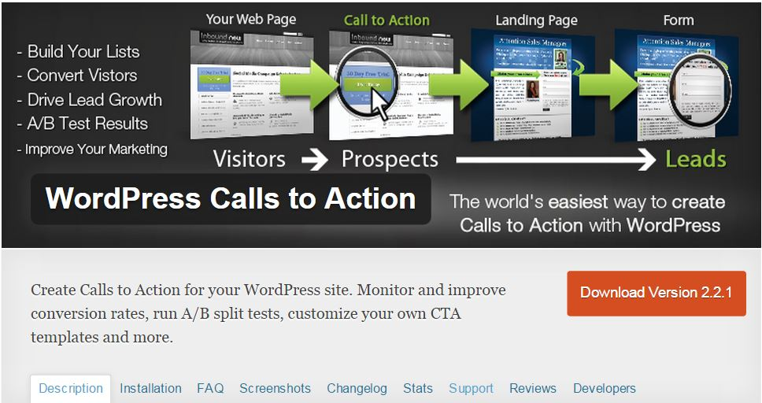

With CTA you may create A/B test, but there's something even better for No Sweat Mass Page creator Users.

The plugin gives you a shortcode to insert the test inside you post. Easy task! Just generate some dummy tests (with no active ads inside), put the shortcodes wherever you want inside you spun article (before generating the project in No Sweat Mass Page Creator!), and once you publish the articles, the code will be there, waiting for you to add some content inside.

After some days, you may edit the Call to Action A/B test and insert the ad or ads you want to display. You may change them, modify etc. and the changes will be there, in all your posts immediately!

  - Wp Inject

Ok, the problem with automatically generated articles is that they always look the same…or do they?

This plugin will help us use different images so that not all the posts have the same look and feel.

If you invested in (or invest now, you still have time) the tactics and strategy upgrade, have a look at the tips & tricks document to know how to do it!

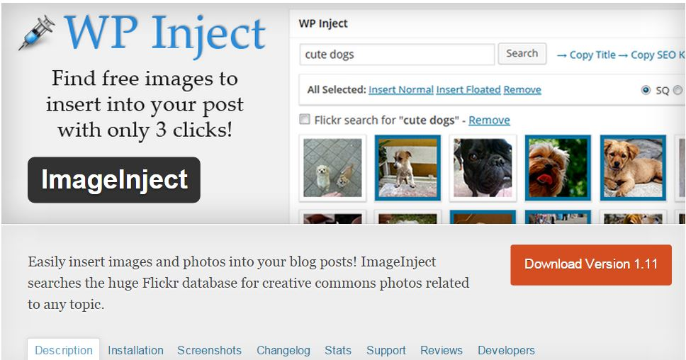

Plugins Only for Advanced Users

  - ELI's SQL Admin Reports Shortcode and DB Backup

If we need to obtain and show data directly from the database this is your plugin.

It can be used to run a simple SQL query with a Shortcode inside posts, or to generate more complex reports using their interface.

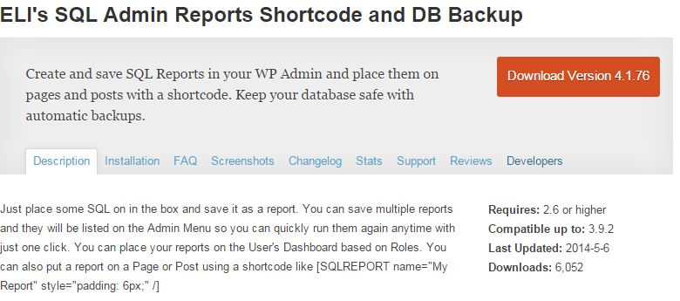

Other Resources to generate dynamic content

The previous plugins help Mass Page Creator users generate and maintain the thousands of post you can create with it.

Sometimes, however, we want to insert more content-rich (and dynamic) content in your posts.

You can include pictures from cities you are writing about, Google maps, weather widgets, etc.

The possibilities are almost endless. The only, requirement is that the resources used must allow the inclusion of parameters inside your post (via shortcodes for example) so you can customize the results for each post.

How can you do that? You can start using your imagination and start using and perusing the plugin, stretching its limits, and you'll surely come up with some awesome ideas we haven't even thought of.

But we have came up with some clever ones to include, for instance, all the dynamic elements mentioned above.

And we explain how to do it in the “No Sweat Mass Page Creator Tactics & Strategy Guide” you can get as a No Sweat Mass Page Creator customer. I definitely think it's worth the tiny investment, in order to make your sites more content-rich and appealing to users.

